Experiment No. 1

1. **Aim:** To study cloud architecture and cloud computing model.
2. **Objectives:** From this experiment, the student will be able to

* provide an overview of concepts of Cloud Computing .
* To encourage students to indulge into research in Cloud Computing.

1. **Hardware / Software Required:** Ubuntu operating system, Internet.
2. **Theory:**

Cloud computing enables companies to consume compute resources as a utility -- just like electricity -- rather than having to build and maintain computing infrastructures in-house. Cloud computing promises several attractive benefits for businesses and end users.

Three of the main benefits of cloud computing include:

• [Self-service provisioning](http://searchcloudprovider.techtarget.com/definition/User-self-provisioning): End users can spin up computing resources for almost any type of workload [on-demand](http://searchdatacenter.techtarget.com/definition/on-demand-computing).

• [Elasticity](http://searchcio.techtarget.com/definition/IT-elasticity): Companies can scale up as computing needs increase and then scale down again as demands decreases.

[Pay per use](http://searchcio.techtarget.com/definition/metered-services): Computing resources are measured at a granular level, allowing users to pay only for the resources and workloads they use.

Cloud computing services can be [Private](http://searchcloudcomputing.techtarget.com/definition/private-cloud), [Public](http://searchcloudcomputing.techtarget.com/definition/public-cloud) or [Hybrid](http://searchcloudcomputing.techtarget.com/definition/hybrid-cloud).

Private cloud services are delivered from a business' data center to internal users. This model offers versatility and convenience, while preserving management, control and security. Internal customers may or may not be billed for services through [IT chargeback](http://searchaws.techtarget.com/definition/IT-chargeback-showback).

In the Public cloud model, a third-party provider delivers the cloud service over the Internet. Public cloud services are sold on-demand, typically by the minute or the hour. Customers only pay for the [CPU](http://whatis.techtarget.com/definition/CPU-central-processing-unit) cycles, [storage](http://searchstorage.techtarget.com/definition/storage) or [bandwidth](http://searchenterprisewan.techtarget.com/definition/bandwidth) they consume.  Leading public cloud providers include Amazon Web Services ([AWS](http://whatis.techtarget.com/definition/Amazon-Web-Services-AWS)), Microsoft [Azure](http://searchwindowsserver.techtarget.com/definition/Microsoft-Azure-Windows-Azure), IBM/SoftLayer and [Google Compute Engine](http://searchaws.techtarget.com/definition/Google-Compute-Engine).

Hybrid cloud is a combination of public cloud services and on-premises private cloud – with orchestration and automation between the two.

Companies can run mission-critical workloads or sensitive applications on the private cloud while using the public cloud for[bursty](http://searchcloudcomputing.techtarget.com/definition/cloud-bursting) workloads that must scale on-demand. The goal of hybrid cloud is to create a unified, automated, scalable environment which takes advantage of all that a public cloud infrastructure can provide, while still maintaining control over mission-critical data.

Types of cloud computing:

IT people talk about three different kinds of cloud computing, where different services are being provided for you. Note that there's a certain amount of vagueness about how these things are defined and some overlap between them.

* Infrastructure as a Service (IaaS) means you're buying access to raw computing hardware over the Net, such as servers or storage. Since you buy what you need and pay-as-you-go, this is often referred to as utility computing. Ordinary web hosting is a simple example of IaaS: you pay a monthly subscription or a per-megabyte/gigabyte fee to have a hosting company serve up files for your website from their servers.
* Software as a Service (SaaS) means you use a complete application running on someone else's system. Web-based email and Google Documents are perhaps the best-known examples. Zoho is another well-known SaaS provider offering a variety of office applications online.
* Platform as a Service (PaaS) means you develop applications using Web-based tools so they run on systems software and hardware provided by another company. So, for example, you might develop your own ecommerce website but have the whole thing, including the shopping cart, checkout, and payment mechanism running on a merchant's server. Force.com (from salesforce.com) and the Google App Engine are examples of PaaS.
* Advantages and disadvantages of cloud computing

Advantages: The pros of cloud computing are obvious and compelling. If your business is selling books or repairing shoes, why get involved in the nitty gritty of buying and maintaining a complex computer system? If you run an insurance office, do you really want your sales agents wasting time running anti-virus software, upgrading word-processors, or worrying about hard-drive crashes? Do you really want them cluttering your expensive computers with their personal emails, illegally shared [MP3](http://www.explainthatstuff.com/how-mp3players-work.html) files, and naughty YouTube videos—when you could leave that responsibility to someone else? Cloud computing allows you to buy in only the services you want, when you want them, cutting the upfront capital costs of computers and peripherals. You avoid equipment going out of date and other familiar IT problems like ensuring system security and reliability. You can add extra services (or take them away) at a moment's notice as your business needs change. It's really quick and easy to add new applications or services to your business without waiting weeks or months for the new computer (and its software) to arrive.

Disadvantages: Instant convenience comes at a price. Instead of purchasing computers and software, cloud computing means you buy services, so one-off, upfront capital costs become ongoing operating costs instead. That might work out much more expensive in the long-term.

If you're using software as a service (for example, writing a report using an online word processor or sending emails through webmail), you need a reliable, high-speed, [broadband](http://www.explainthatstuff.com/howbroadbandworks.html) Internet connection functioning the whole time you're working. That's something we take for granted in countries such as the United States, but it's much more of an issue in developing countries or rural areas where broadband is unavailable.

If you're buying in services, you can buy only what people are providing, so you may be restricted to off-the-peg solutions rather than ones that precisely meet your needs. Not only that, but you're completely at the mercy of your suppliers if they suddenly decide to stop supporting a product you've come to depend on. (Google, for example, upset many users when it [announced](http://www.zdnet.com/google-apps-axes-export-support-for-doc-and-other-old-microsoft-office-formats-7000004884/) in September 2012 that its cloud-based Google Docs would drop support for old but de facto standard Microsoft Office file formats such as .DOC, .XLS, and .PPT, giving a mere one week's notice of the change—although, after public pressure, it later extended the deadline by three months.) Critics charge that cloud-computing is a return to the bad-old days of mainframes and proprietary systems, where businesses are locked into unsuitable, long-term arrangements with big, inflexible companies. Instead of using "generative" systems (ones that can be added to and extended in exciting ways the developers never envisaged), you're effectively using "dumb terminals" whose uses are severely limited by the supplier. Good for convenience and security, perhaps, but what will you lose in flexibility? And is such a restrained approach good for the future of the Internet as a whole? (To see why it may not be, take a look at Jonathan Zittrain's eloquent book [The Future of the Internet—And How to Stop It](http://futureoftheinternet.org/).)

1. **Conclusion:** Cloud computing enables a convenient and on-demand network access to a wide range of resources. The different services and also the deployment models allow flexible service provider interaction with minimal human intervention. It saves costs but also can lead to risk issues and suspension of resources when in huge quantity.

Experiment No. 2

1. **Aim:** Installation and Configuration of virtualization using KVM
2. **Objectives:** From this experiment, the student will be able to,

* Understand the concepts of virtualization.
* Understand KVM architecture and its configuration.

1. **Hardware / Software Required:** Ubuntu operating system, open source software KVM, Internet.
2. **Theory:**

Virtualization is software that separates physical infrastructures to create various dedicated resources. It is the fundamental technology that powers cloud computing.

The technology behind virtualization is known as a virtual machine monitor (VMM) or virtual manager, which separates compute environments from the actual physical infrastructure.

Virtualization makes servers, workstations, storage and other systems independent of the physical hardware layer. This is done by installing a Hypervisor on top of the hardware layer, where the systems are then installed.

There are three areas of IT where virtualization is making headroads, network virtualization, storage virtualization and server virtualization:

• Network virtualization is a method of combining the available resources in a network by splitting up the available bandwidth into channels, each of which is independent from the others, and each of which can be assigned (or reassigned) to a particular server or device in real time. The idea is that virtualization disguises the true complexity of the network by separating it into manageable parts, much like your partitioned hard drive makes it easier to manage your files.

• Storage virtualization is the pooling of physical storage from multiple network storage devices into what appears to be a single storage device that is managed from a central console. Storage virtualization is commonly used in storage area networks (SANs).

• Server virtualization is the masking of server resources (including the number and identity of individual physical servers, processors, and operating systems) from server users. The intention is to spare the user from having to understand and manage complicated details of server resources while increasing resource sharing and utilization and maintaining the capacity to expand later.

Virtualization can be viewed as part of an overall trend in enterprise IT that includes autonomic computing, a scenario in which the IT environment will be able to manage itself based on perceived activity, and utility computing, in which computer processing power is seen as a utility that clients can pay for only as needed. The usual goal of virtualization is to centralize administrative tasks while improving scalability and work loads.

1. **Procedure:**

Installation Steps :

1. #sudo grep -c "svm\|vmx" /proc/cpuinfo

2. #sudo apt-get install qemu-kvm libvirt-bin bridge-utils virt-manager

3. #sudoadduserrait

#sudoadduserraitlibvirtd

After running this command, log out and log back in as rait

4. Run following command after logging back in as rait and you should see an empty list of virtual machines. This indicates that everything is working correctly.

#virsh -c qemu:///system list

5. Open Virtual Machine Manager application and Create Virtual Machine

#virt-manager

1. **Result:**

_____________________________SNAPSHOTS____________________________

Step 1 : #sudo grep -c "svm\|vmx" /proc/cpuinfo

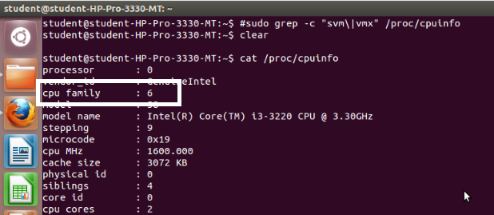

Step 2 : #sudo apt-get install qemu-kvm libvirt-bin bridge-utils virt-manager

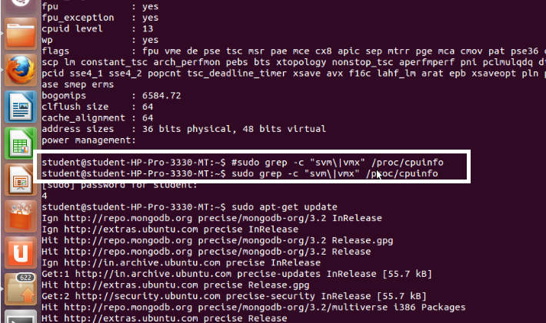

Step 3 : #sudoadduserrait

After running this command, log out and log back in as rait

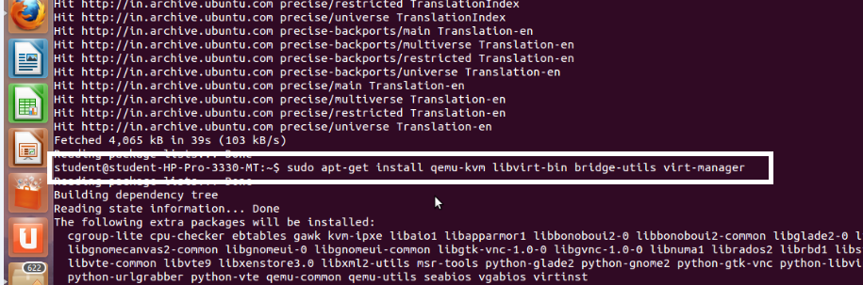

Step 4 : #sudoadduserraitlibvirtd

After running this command, log out and log back in as rait

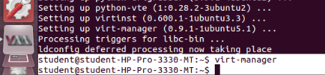

Step 5 : Open Virtual Machine Manager application and Create Virtual Machine

#virt-manager as shown below

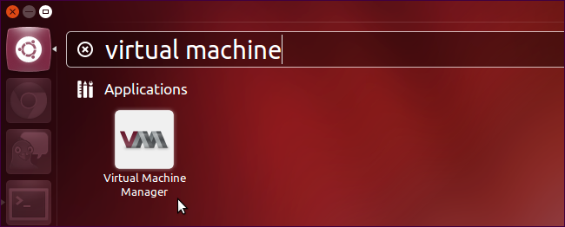

Step 6 : Create a new virtual machine as shown below

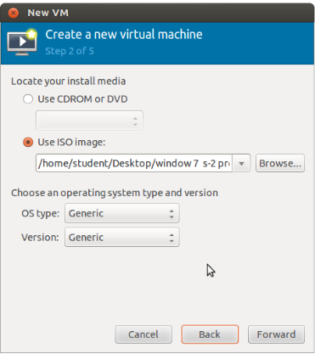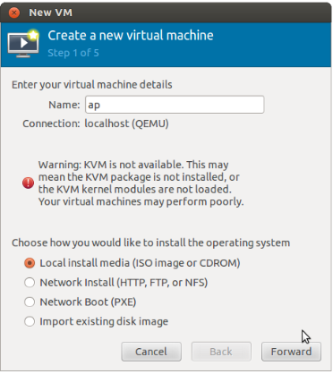

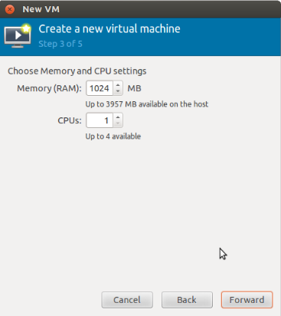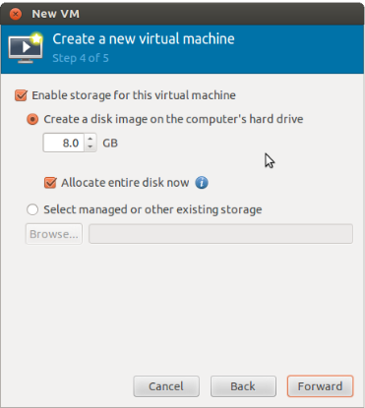

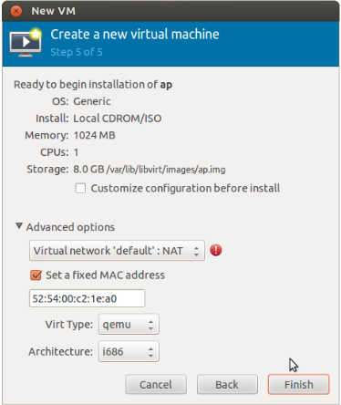

Step 7 : Install windows operating system on virtual machine

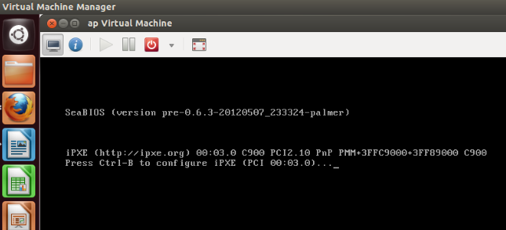

Step 8: Installation of windows on virtual machine

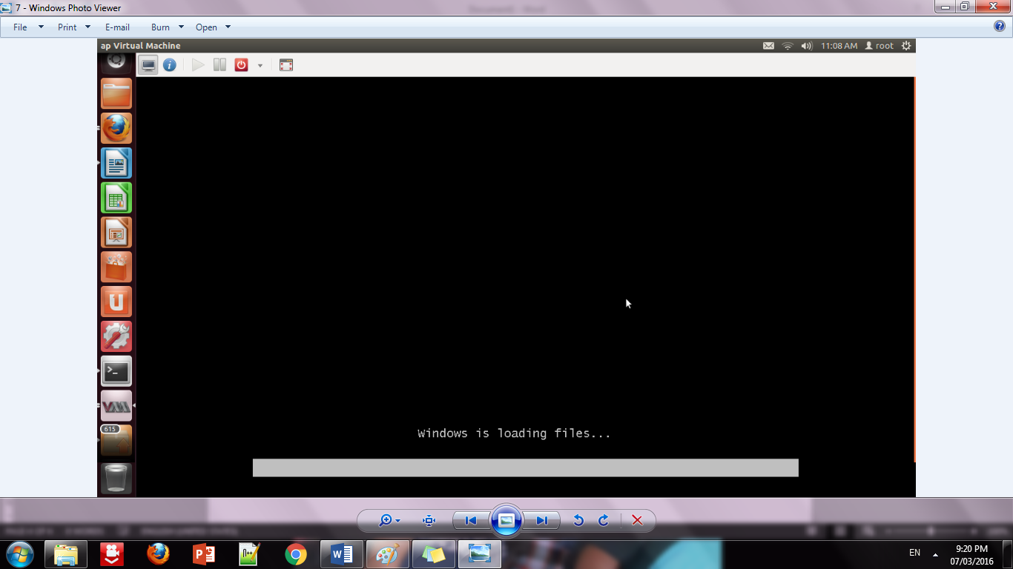

Step 9: Installation of windows 7 on virtual machine

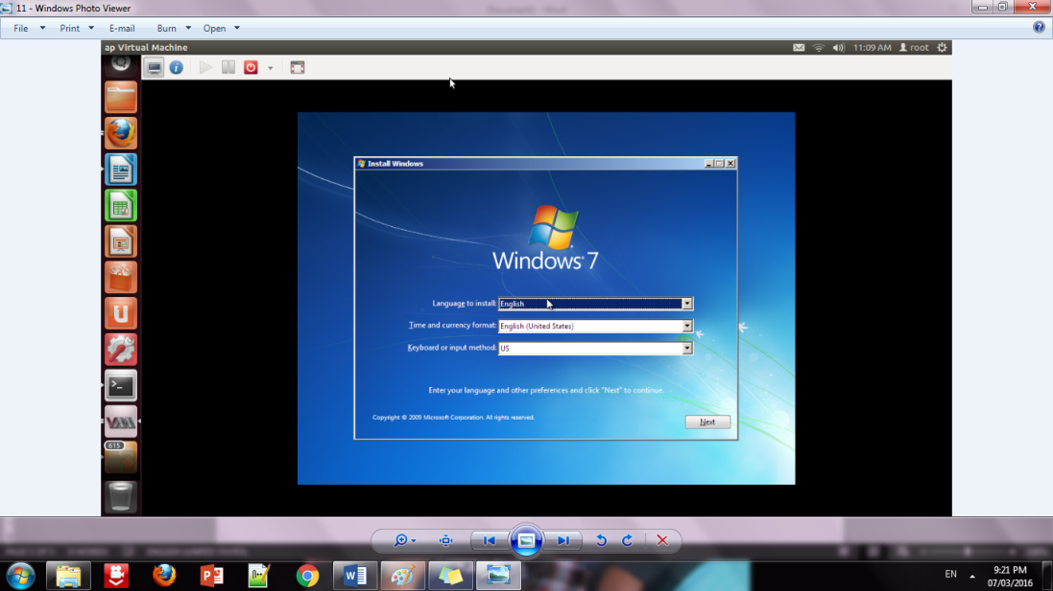

Step 10: Initialization of windows on virtual machine

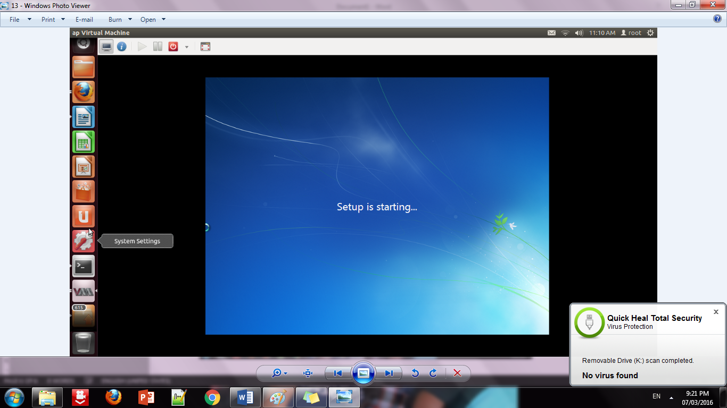

1. **Conclusion:**

Installation and configuration of KVM have been done successfully onto Ubantu and users added. Like this we can create as many virtual machines as possible on OS and can install any windows onto it.

Experiment No. 3

1. **Aim:** To study and implementation of Infrastructure as a Service
2. **Objectives:** From this experiment, the student will be able to,

* Understand concepts of virtualization and to use cloud as Infrastructure as a services.
* Learn the technique and its complexity
* Understand the importance of this technique from application point of view

1. **Hardware / Software Required:** Ubuntu operating system, Virtual machine, WAMP/ZAMP server, Any tool or technology can be used for implementation of web application e.g., JAVA, PHP, etc.
2. **Theory:**

Infrastructure as a Service (IaaS) is one of the three fundamental service

models of cloud computing alongside Platform as a Service (PaaS) and Software as a Service (SaaS). As with all cloud computing services it provides access to computing resource in a virtualised environment, “the Cloud”, across a public connection, usually the internet. In the case of IaaS the computing resource provided is specifically that of virtualised hardware, in other words, computing infrastructure. The definition includes such offerings as virtual server space, network connections, bandwidth, IP addresses and load balancers. Physically, the pool of hardware resource is pulled from a multitude of servers and networks usually distributed across numerous data centers, all of which the cloud provider is responsible for maintaining. The client, on the other hand, is given access to the virtualised components in order to build their own IT platforms.

In common with the other two forms of cloud hosting, IaaS can be utilised by enterprise customers to create cost effective and easily scalable IT solutions where the complexities and expenses of managing the underlying hardware are outsourced to the cloud provider. If the scale of a business customer’s operations fluctuate, or they are looking to expand, they can tap into the cloud resource as and when they need it rather than purchase, install and integrate hardware themselves.

IaaS customers pay on a per-use basis, typically by the hour, week or month. Some providers also charge customers based on the amount of virtual machine space they use. This pay-as-you-go model eliminates the capital expense of deploying in-house hardware and software. However, users should monitor their IaaS environments closely to avoid being charged for unauthorized services.

Because IaaS providers own the infrastructure, systems management and monitoring may become more difficult for users. Also, if an IaaS provider experiences downtime, users' workloads may be affected.

For example, if a business is developing a new software product, it might be more cost-effective to host and test the application through an IaaS provider. Once the new software is tested and refined, it can be removed from the IaaS environment for a more traditional in-house deployment or to save money or free the resources for other projects.

Leading IaaS providers include Amazon Web Services (AWS), Windows Azure, Google Compute Engine, Rackspace Open Cloud, and IBM SmartCloud Enterprise.

1. **Procedure:**

**Installation Steps:**

a. Openstack using devstack

b. Sudo apt-get install git

c. Git clone https://git.openstack.org/openstack-dev/devstack

d. Cd devstack

e. Is (you can see stack.sh in the list)

f. ./stck.sh

g. Give password as many time it asks

h. ls –ls come out of devstack

i. sudo chmod777devstack

j. cd devstack

k. ./stack.sh

**Conclusion:** We have installed Xen as bare metal hypervisor and implemented it. It provides access to computing resources in a virtual environment. With the help of Infrastructure as a service we can build our own IT platform. We can install Windows Operating System on Ubuntu and vice versa.

Experiment No. 4

1. **Aim:** To study and implementation of Storage as a Service
2. **Objectives:** From this experiment, the student will be able to

* To make the students understand use of cloud as Platform, Storage as a services.
* To learn the efficient tools to implement the technique.

1. **Hardware / Software Required:** Ubuntu operating system, Virtual machine, WAMP/ZAMP server, Any tool or technology can be used for implementation of web application e.g., JAVA, PHP, etc
2. **Theory:**

**Collaborating on Word Processing:**

You use your word processor most likely some version of Microsoft Word—to write memos, letters, thank you notes, fax coversheets, reports, newsletters, you name it. The word processor is an essential part of our computing lives. There are a number of web-based replacements for Microsoft’s venerable Word program are available. All of these programs let you write your letters and memos and reports from any computer, no installed software necessary, as long as that computer has a connection to the Internet. And every document you create is housed on the web, so you don’t have to worry about taking your work with you. It’s cloud computing at its most useful, and it’s here today.

**Exploring Web-Based Word Processors:**

There are a half-dozen or so really good web-based word processing applications, led by the ever-popular Google Docs. We’ll start our look at these applications with Google’s application and work through the rest in alphabetic order.

**Google Docs:**

Google Docs (docs.google.com) is the most popular web-based word processor available today. Docs is actually a suite of applications that also includes Google Spreadsheets and Google Presentations; the Docs part of the Docs suite is the actual word processing application. Like all things Google, the Google Docs interface is clean and, most important, it works well without imposing a steep learning curve. Basic formatting is easy enough to do, storage space for your documents is generous, and sharing collaboration version control is a snap to do. When you log in to Google Docs with your Google account, you see the page. This is the home page for all the Docs applications (word processing, spreadsheets, and presentations); all your previously created documents are listed on this page. The leftmost pane helps you organize your documents. You can store files in folders, view documents by type (word processing document or spreadsheet), and display documents shared with specific people.

**Collaborating on Spreadsheets :**

If the word processor is the most-used office application, the spreadsheet is the second most-important app. Office users and home users alike use spreadsheets to prepare budgets, create expense reports, perform “what if” analyses, and otherwise crunch their numbers. And thus we come to those spreadsheets in the cloud, the web-based spreadsheets that let you share your numbers with other users via the Internet. All the advantages of webbased word processors apply to web-based spreadsheets— group collaboration, anywhere/anytime access, portability, and so on.

**Exploring Web-Based Spreadsheets:**

Several web-based spreadsheet applications are worthy competitors to Microsoft Excel. Chief among these is Google Spreadsheets, which we’ll discuss first, but there are many other apps that also warrant your attention. If you’re at all interested in moving your number crunching and financial analysis into the cloud, these web-based applications are worth checking out.

**Google Spreadsheets**

Google Spreadsheets was Google’s first application in the cloud office suite first known as Google Docs & Spreadsheets and now just known as Google Docs. As befits its longevity, Google Spreadsheets is Google’s most sophisticated web-based application. You access your existing and create new spreadsheets from the main Google Docs page (docs.google.com). To create a new spreadsheet, click the New button and select Spreadsheet; the new spreadsheet opens in a new window and you can edit it.

**Collaborating on Presentations:**

One of the last components of the traditional office suite to move into the cloud is the presentation application. Microsoft PowerPoint has ruled the desktop forever, and it’s proven difficult to offer competitive functionality in a web-based application; if nothing else, slides with large graphics are slow to upload and download in an efficient manner. That said, there is a new crop of web-based presentation applications that aim to give PowerPoint a run for its money. The big players, as might be expected, are Google and Zoho, but there are several other applications that are worth considering if you need to take your presentations with you on the road—or collaborate with users in other locations.

**Google Presentations:**

If there’s a leader in the online presentations market, it’s probably Google Presentations, simply because of Google’s dominant position with other webbased office apps. Google Presentations is the latest addition to the Google Docs suite of apps, joining the Google Docs word processor and Google Spreadsheets spreadsheet application. Users can create new presentations and open existing ones from the main Google Docs page (docs.google.com). Open a presentation by clicking its title or icon. Create a new presentation by selecting New, then Presentation. Your presentation now opens in a new window on your desktop. What you do get is the ability to add title, text, and blank slides; a PowerPoint-like slide sorter pane; a selection of predesigned themes. the ability to publish your file to the web or export as a PowerPoint PPT or Adobe PDF file; and quick and easy sharing and collaboration, the same as with Google’s other web-based apps.

**Collaborating on Databases:**

A database does many of the same things that a spreadsheet does, but in a different and often more efficient manner. In fact, many small businesses use spreadsheets for database-like functions. A local database is one in which all the data is stored on an individual computer. A networked database is one in which the data is stored on a computer or server connected to a network, and accessible by all computers connected to that network. Finally, an online or web-based database stores data on a cloud of servers somewhere on the Internet, which is accessible by any authorized user with an Internet connection. The primary advantage of a web-based database is that data can easily be shared with a large number of other users, no matter where they may be located. When your employee database is in the cloud.

**Exploring Web-Based Databases:**

In the desktop computing world, the leading database program today is Microsoft Access. (This wasn’t always the case; dBase used to rule the database roost, but things change over time.) In larger enterprises, you’re likely to encounter more sophisticated software from Microsoft, Oracle, and other companies. Interestingly, none of the major database software developers currently provide web-based database applications. Instead, you have to turn to a handful of start-up companies (and one big established name) for your online database needs.

**Cebase**

Cebase (www.cebase.com) lets you create new database applications with a few clicks of your mouse; all you have to do is fill in a few forms and make a few choices from some pull-down lists. Data entry is via web forms, and then your data is displayed in a spreadsheet-like layout, You can then sort, filter, and group your data as you like. Sharing is accomplished by clicking the Share link at the top of any data page. You invite users to share your database via email, and then adjust their permissions after they’ve accepted your invitation.

1. **Result:**

_____________________________SNAPSHOTS_______________________________

Step 1: Sign into the Google Drive website with your Google account.

If you don’t have a Google account, you can create one for free. Google Drive will allow you to store your files in the cloud, as well as create documents and forms through the Google Drive web interface.

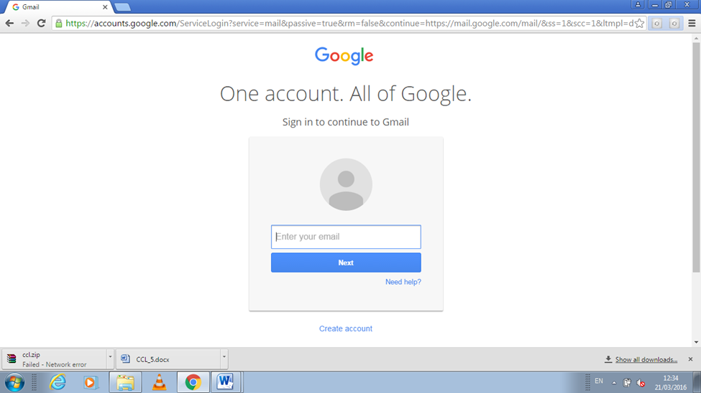

Step 2: Add files to your drive.

There are two ways to add files to your drive. You can create Google Drive documents, or you can upload files from your computer. To create a new file, click the CREATE button. To upload a file, click the “Up Arrow” button next to the CREATE button.

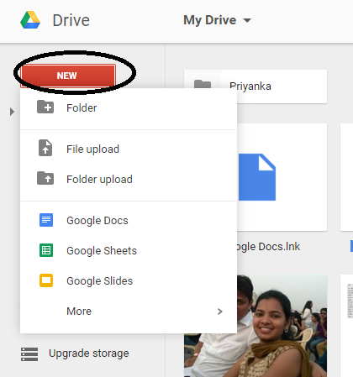

Step 3: Change the way your files are displayed.

You can choose to display files by large icons (Grid) or as a list (List). The List mode will show you at a glance the owner of the document and when it was last modified. The Grid mode will show each file as a preview of its first page. You can change the mode by clicking the buttons next to the gear icon in the upper right corner of the page.

// List Mode

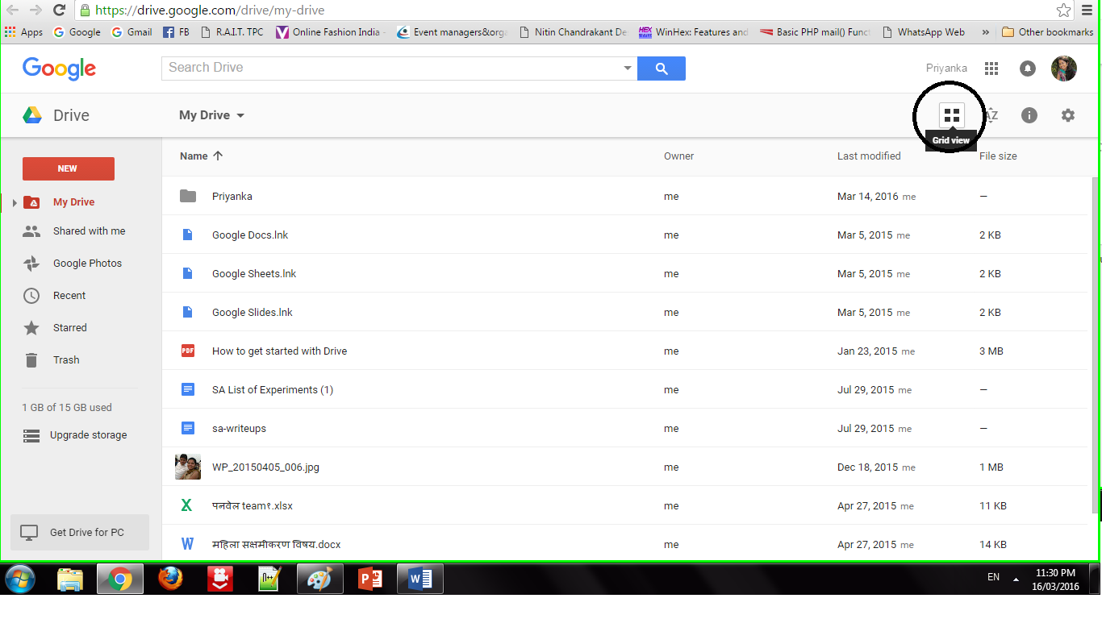

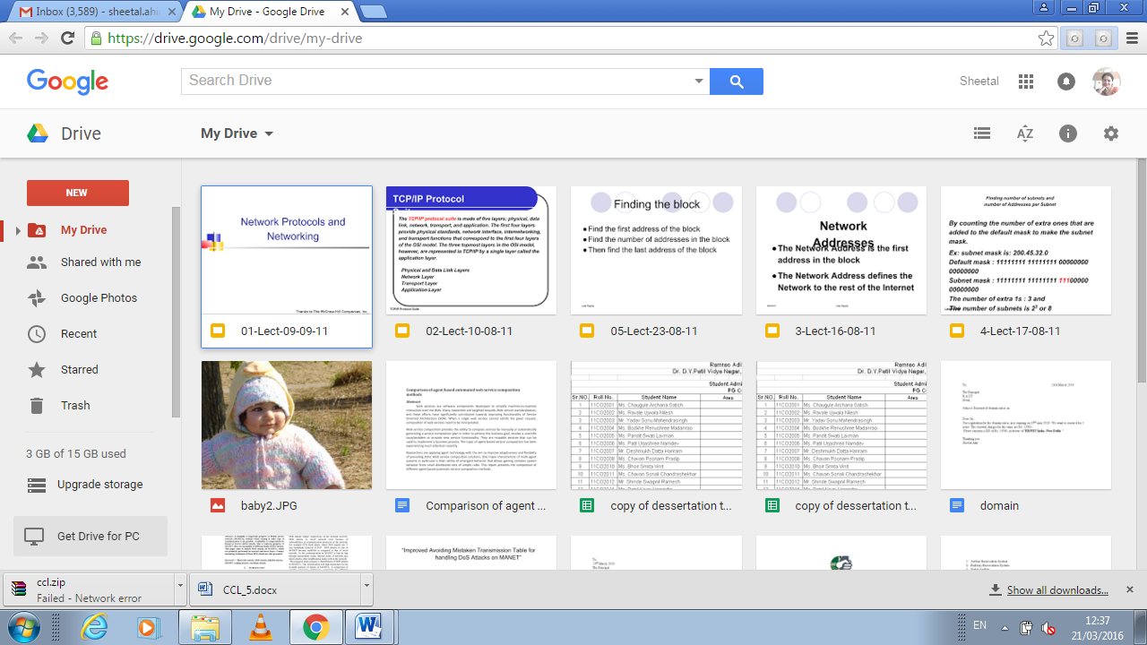

Step 4: Use the navigation bar on the left side to browse your files.

“My Drive” is where all of your uploaded files and folders are stored. “Shared with Me” are documents and files that have been shared with you by other Drive users. “Starred” files are files that you have marked as important, and “Recent” files are the ones you have most recently edited.

•You can drag and drop files and folders around your Drive to organize them as you see fit.

•Click the Folder icon with a “+” sign to create a new folder in your Drive. You can create folders inside of other folders to organize your files.

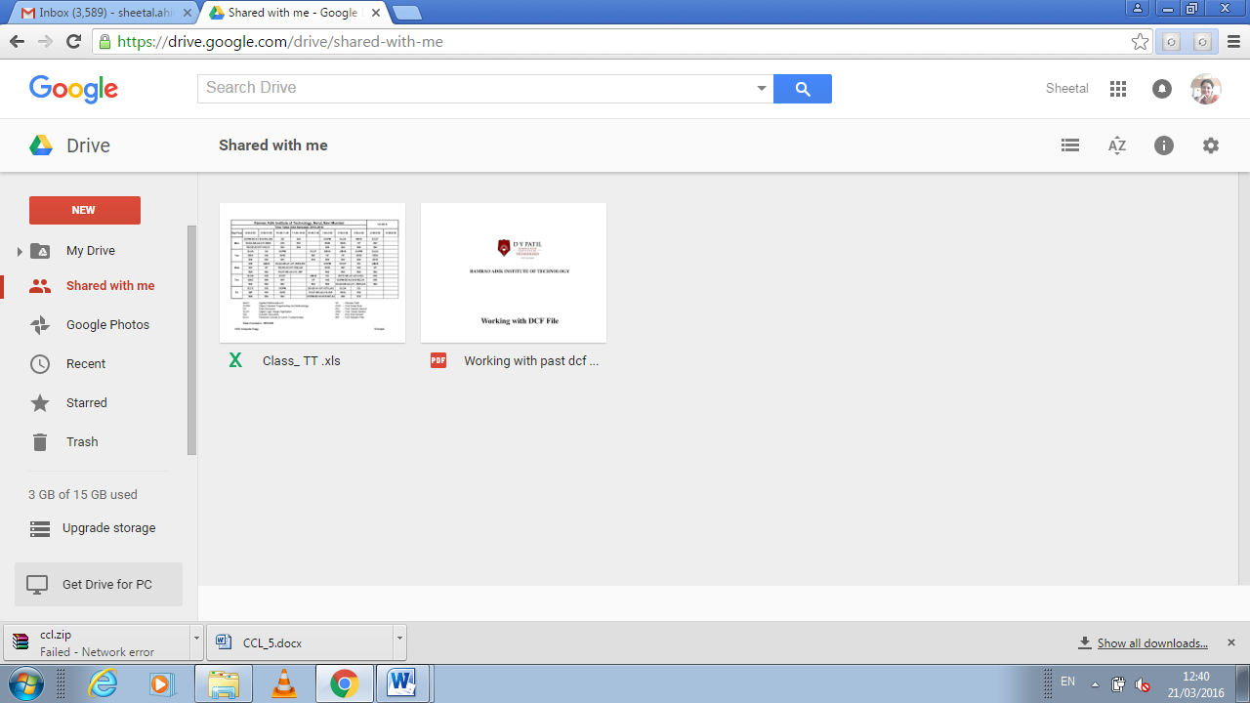

Step 5: Search for files.

You can search through your Google Drive documents and folders using the search bar at the top of your page. Google Drive will search through titles, content, and owners. If a file is found with the exact term in the title, it will appear under the search bar as you type so that you can quickly select it.

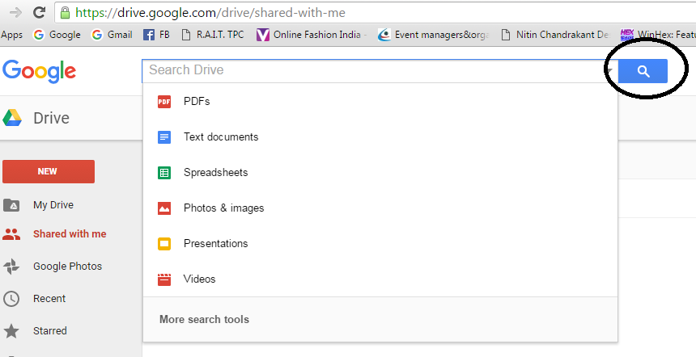

Step 1: Click the NEW button.

A menu will appear that allows you to choose what type of document you want to create. You have several options by default, and more can be added by clicking the “More “ link at the bottom of the menu:

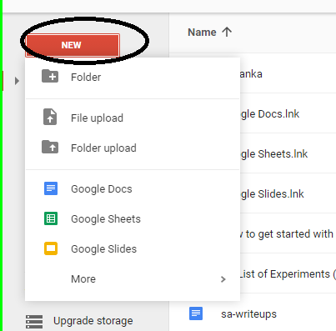

Step 2: Create a new file.

Once you’ve selected your document type, you will be taken to your blank document. If you chose Google Docs/Sheets/Slides , you will be greeted by a wizard that will help you configure the feel of your document.

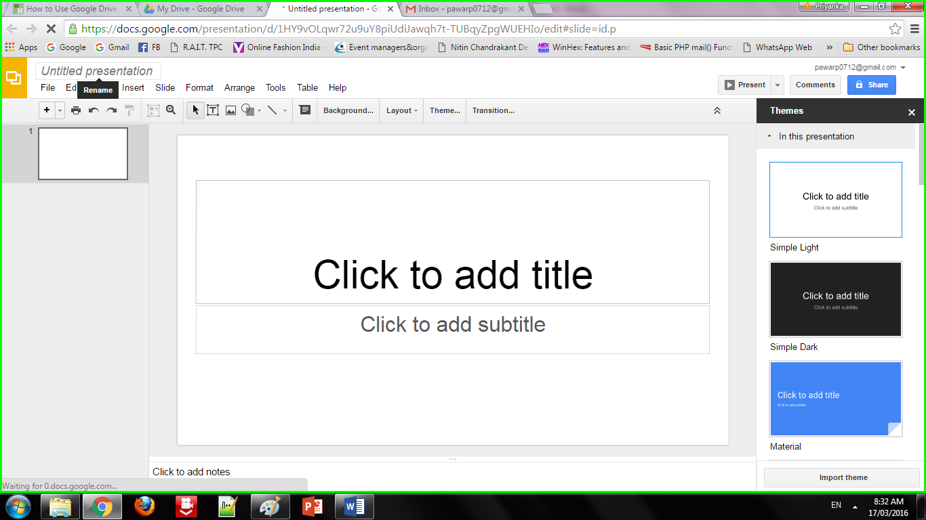

Step 3: Name the file.

At the top of the page, click the italic gray text that says “Untitled <file type>”. When you click it, the “Rename document” window will appear, allowing you to change the name of your file.

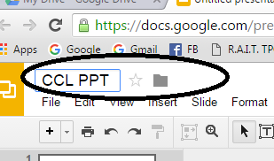

Step 4: Edit your document.

Begin writing your document as you would in its commercially-equivalent. You will most likely find that Google Drive has most of the basic features, but advanced features you may be used to are not available.

1.Your document saves automatically as you work on it.

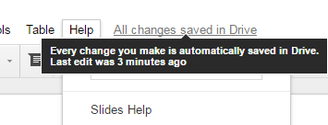

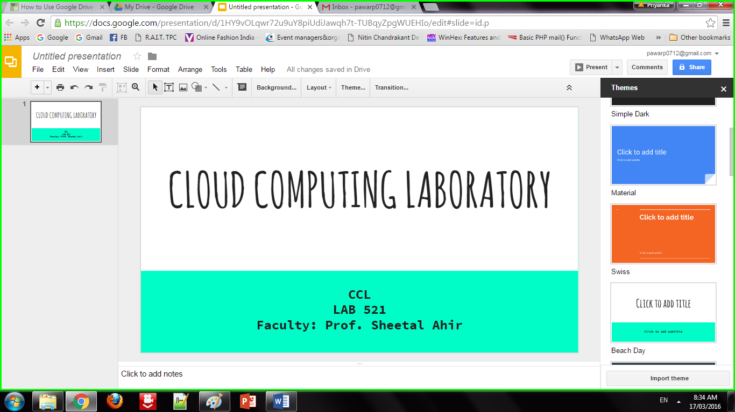

Step 5: Export and convert the file.

If you want to make your file compatible with similar programs, click File and place your cursor over “Download As”. A menu will appear with the available formats. Choose the format that best suits your needs. You will be asked to name the file and select a download location. When the file is downloaded, it will be in the format you chose.

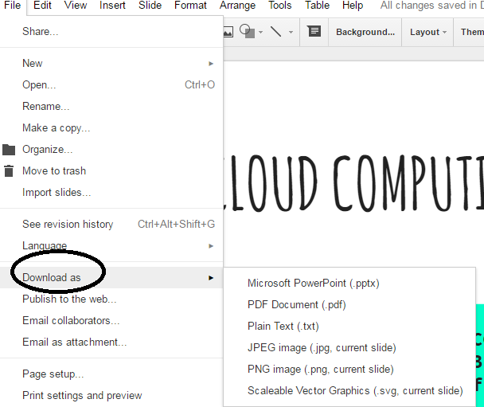

Step 6: Share your document.

Click File and select Share, or click the blue Share button in the upper right corner to open the Sharing settings. You can specify who can see the file as well as who can edit it.

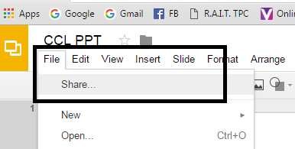

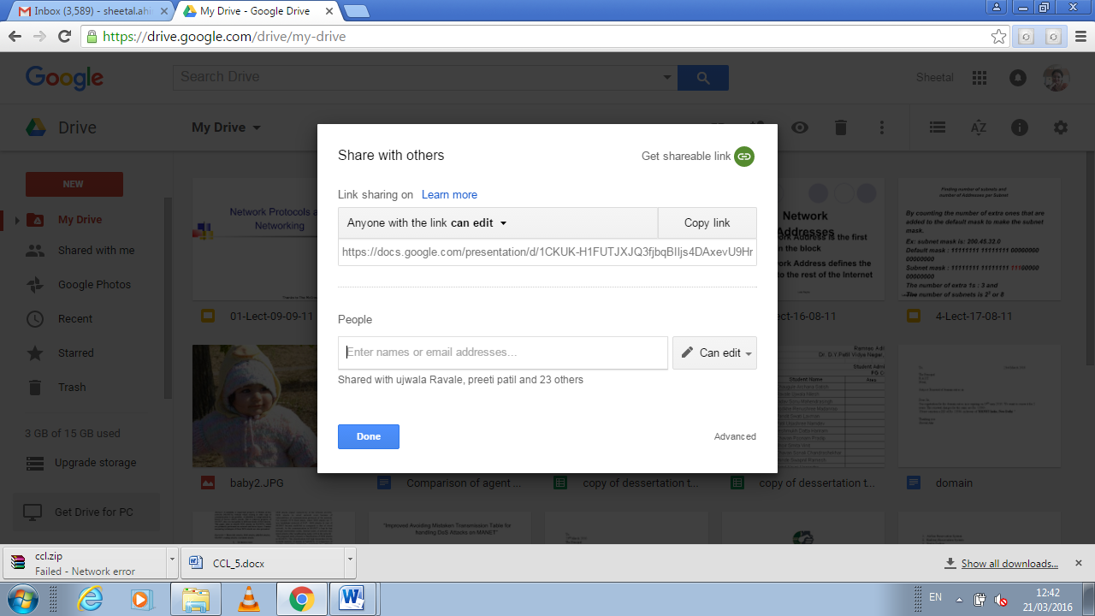

Other Capabilities

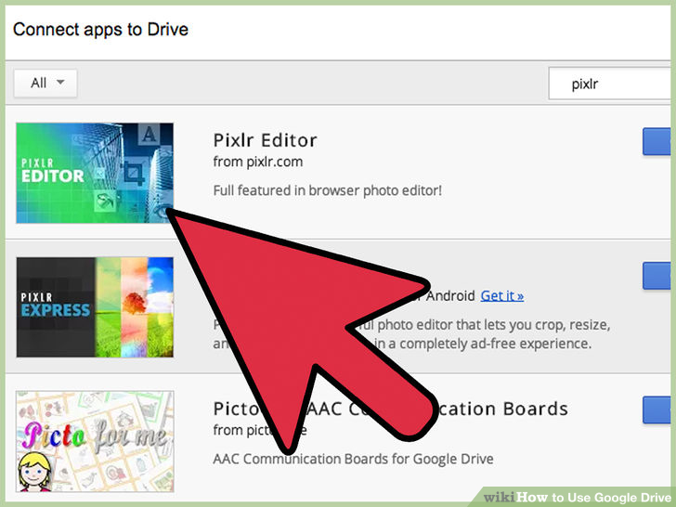

1. Edit photos

2. Listen Music

3. Do drawings

4. Merge PDFs

1. **Conclusion:**

Google Docs provide an efficient way for storage of data. It fits well in Storage as a service (SaaS). It has varied options to create documents, presentations and also spreadsheets. It saves documents automatically after a few seconds and can be shared anywhere on the Internet at the click of a button.

Experiment No. 5

1. **Aim:** To Study Cloud Security management
2. **Objectives:** From this experiment, the student will be able,

* To understand the security features of Cloud.
* To learn the technique of application security management and its complexity
* To understand the importance of cloud security management from application point of view

1. **Hardware / Software Required:** Ubuntu operating system, Virtual machine, WAMP/ZAMP server, Any tool or technology can be used for implementation of web application e.g., JAVA, PHP, etc.
2. **Theory:**

Cloud computing security is the set of control-based technologies and policies designed to adhere to regulatory compliance rules and protect information, data applications and infrastructure associated with cloud computing use. Because of the cloud's very nature as a shared resource, identity management, privacy and access control are of particular concern. With more organizations using cloud computing and associated cloud providers for data operations, proper security in these and other potentially vulnerable areas have become a priority for organizations contracting with a cloud computing provider.

Cloud computing security processes should address the security controls the cloud provider will incorporate to maintain the customer's data security, privacy and compliance with necessary regulations. The processes will also likely include a business continuity and databackup plan in the case of a cloud security breach.

**Physical security**

Cloud service providers physically secure the IT hardware (servers, routers, cables etc.) against unauthorized access, interference, theft, fires, floods etc. and ensure that essential supplies (such as electricity) are sufficiently robust to minimize the possibility of disruption. This is normally achieved by serving cloud applications from 'world-class' (i.e. professionally specified, designed, constructed, managed, monitored and maintained) data centers.

**Personnel security**

Various information security concerns relating to the IT and other professionals associated with cloud services are typically handled through pre-, para- and post-employment activities such as security screening potential recruits, security awareness and training programs, proactive security monitoring and supervision, disciplinary procedures and contractual obligations embedded in employment contracts, service level agreements, codes of conduct, policies etc.

**Application security**

Cloud providers ensure that applications available as a service via the cloud (SaaS) are secure by specifying, designing, implementing, testing and maintaining appropriate application security measures in the production environment. Note that - as with any commercial software - the controls they implement may not necessarily fully mitigate all the risks they have identified, and that they may not necessarily have identified all the risks that are of concern to customers. Consequently, customers may also need to assure themselves that cloud applications are adequately secured for their specific purposes, including their compliance obligations.

1. **Procedure:**

Security using MFA(Multi Factor Authentication) device code:

1) goto aws.amazon.com

2) click on "My Account"

3) select "AWS management console" and click on it

4) Give Email id in the required field

if you are registering first time then select "I am a new user" radio button

5) click on "sign in using our secure server" button

6) follow the instruction and complete the formalities

(Note: do not provide any credit card details or bank details)

sign out from

7) Again go to "My Account"

select "AWS management console" and click on it

Sign in again by entering the user name and valid password ( check "I am returning user and my password is" radio button)

Now you are logged in as a Root User

All AWS project can be viewed by you, but you cant make any changes in it or you cant create new thing as you are not paying any charges to amazon (for reason refer step:6)

**To create the user in a root user follow the steps mentioned below:**

1) click on "Identity and Access Management" in security and identity project

2) click in "Users" from dashboard

It will take you to "Create New Users"

click on create new user button

enter the "User Name"

(select "Generate and access key for each user" checkbox, it will create a user with a specific key)

click on "Create" button at right bottom

3) once the user is created click on it

4) go to security credentials tab

5) click on "Create Access Key", it will create an access key for user.

6) click on "Manage MFA device" it will give you one QR code displayed on the screen

you need to scan that QR code on your mobile phone using barcode scanner (install it in mobile phone)you also need to install "Google Authenticator" in your mobile phone to generate the MFA code

7) Google authenticator will keep on generating a new MFA code after every 60 seconds

that code you will have to enter while logging as a user.

Hence, the security is maintained by MFA device code...

one can not use your AWS account even if it may have your user name and password, because MFA code is on your MFA device (mobiel phone in this case) and it is getting changed after every 60 seconds.

**Permissions in user account:**

After creating the user by following above mentioned steps; you can give certain permissions to specific user

1) click on created user

2) goto "Permissions" tab

3) click on "Attach Policy" button

4) select the needed policy from given list and click on apply.

1. **Result:**

Step 1 :goto aws.amazon.com

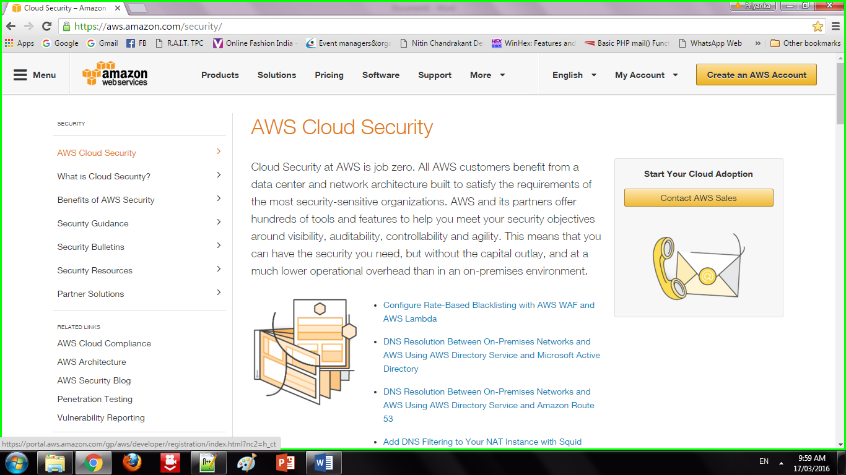

Step 2 : Click on "My Account". Select "AWS management console" and click on it. Give Email id in the required field

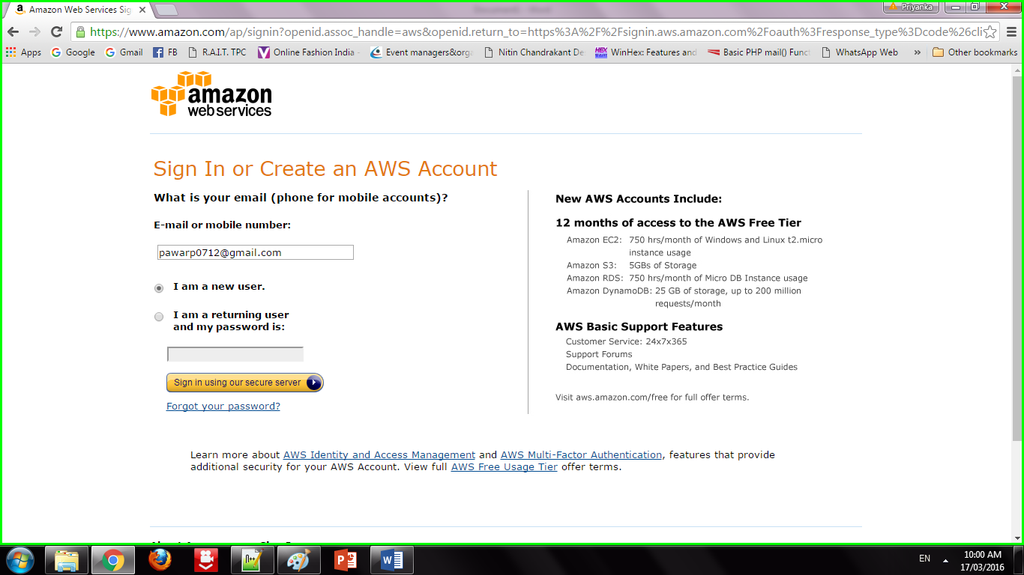

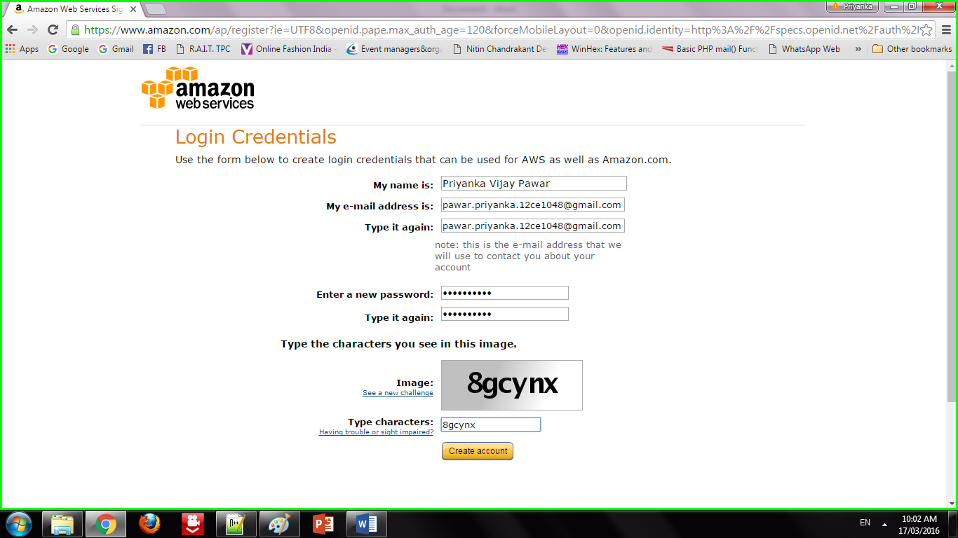

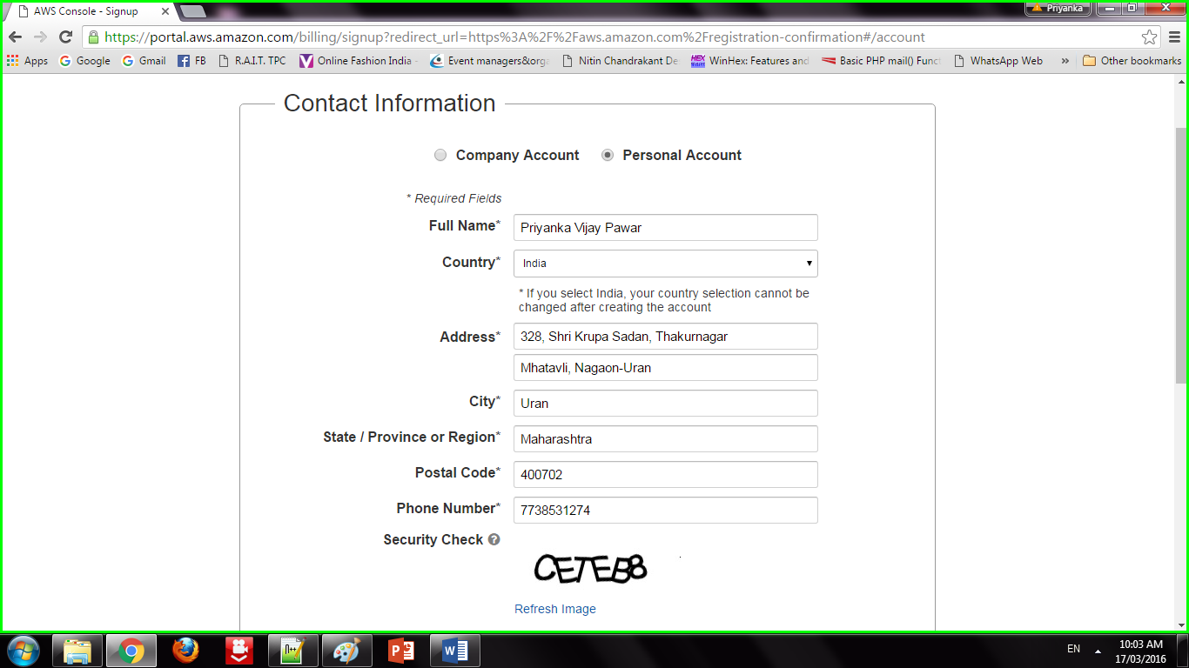

Step 3: Addition of security features

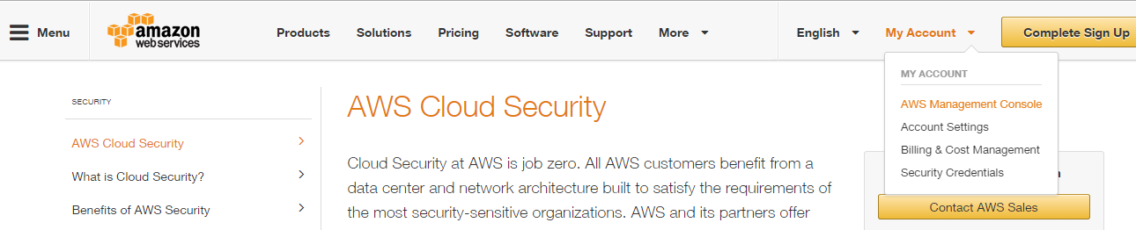

Step 4: Sign in to an AWS account

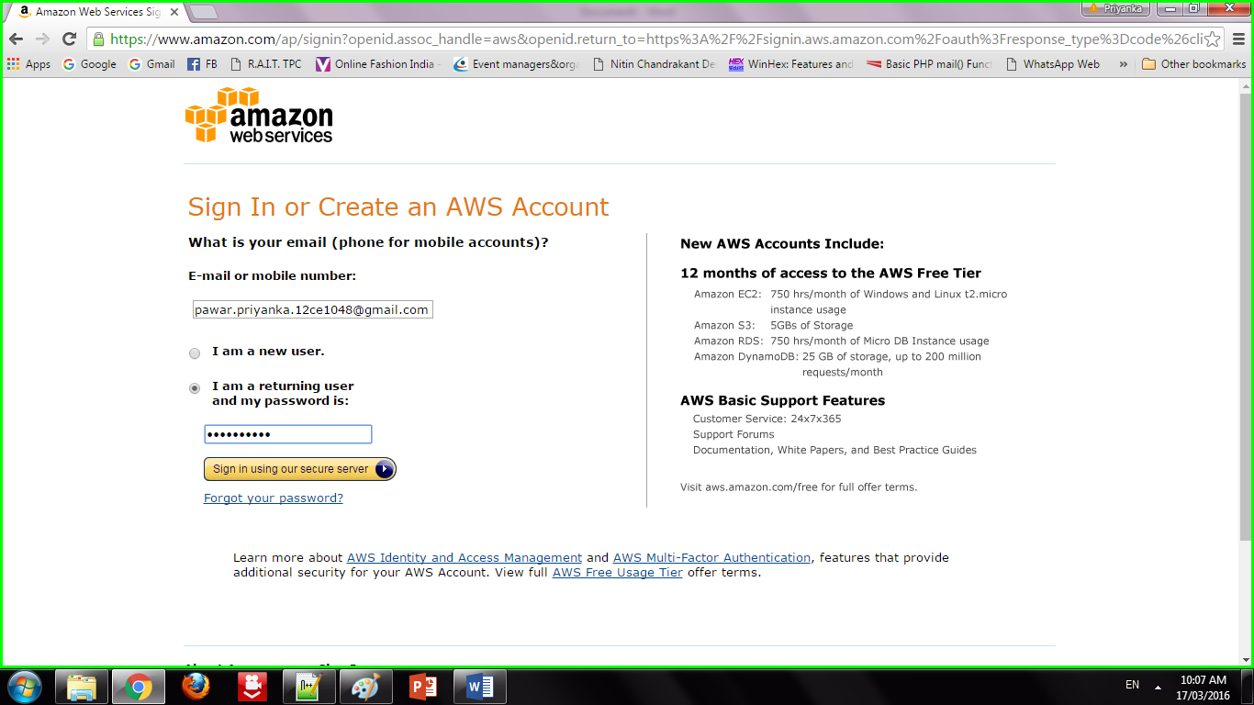

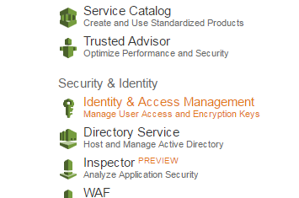

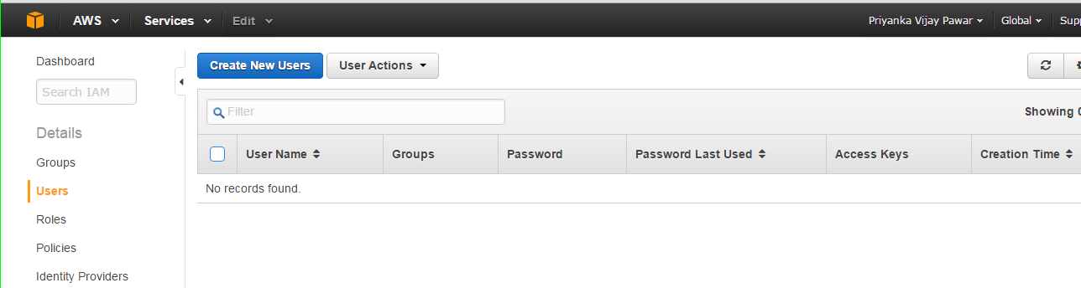

Step 5 : Creation of users

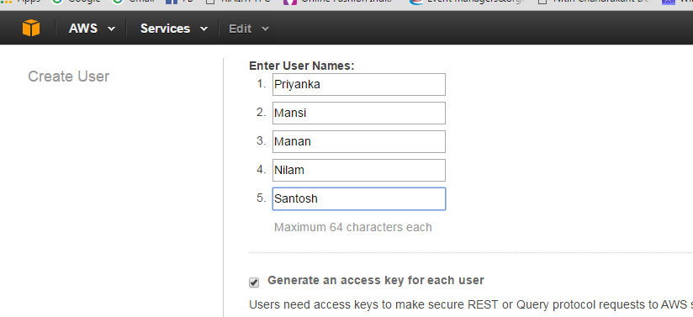

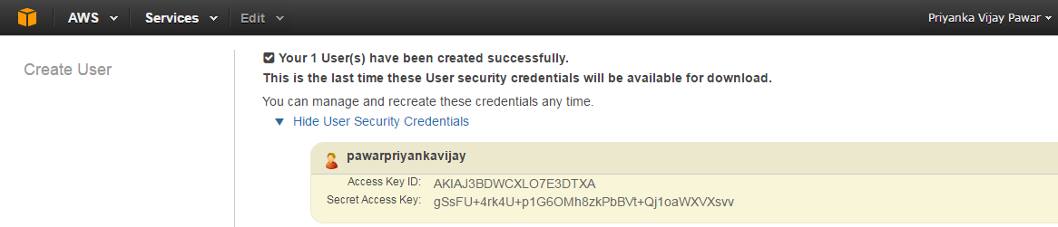

Step 6: Adding users to group

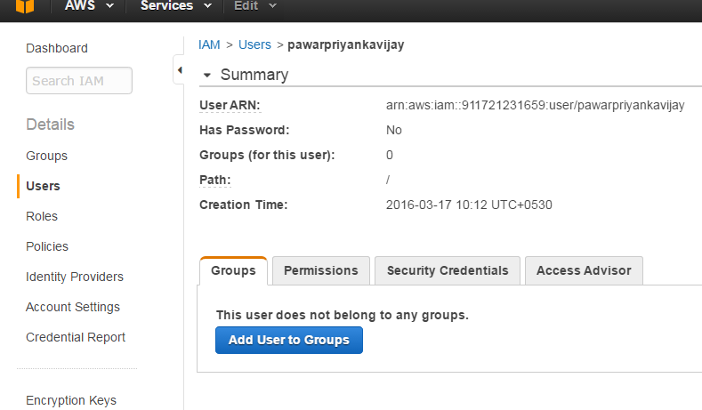

Step 7: Creating Access key

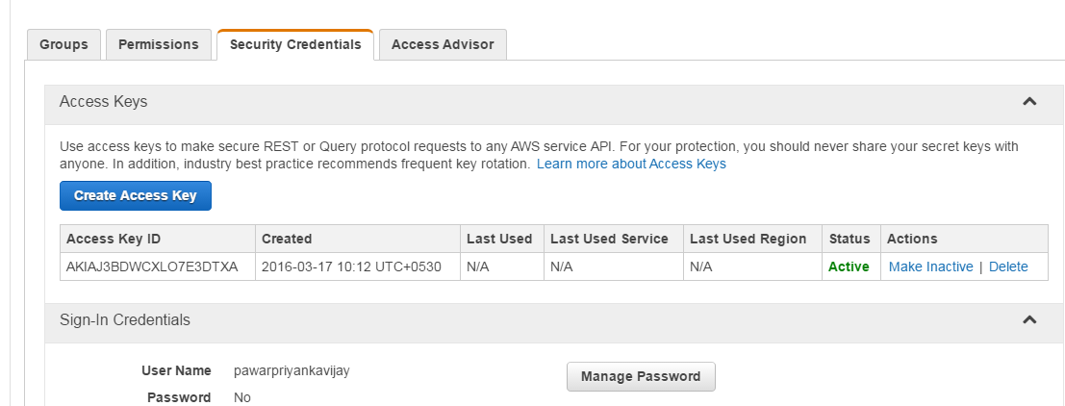

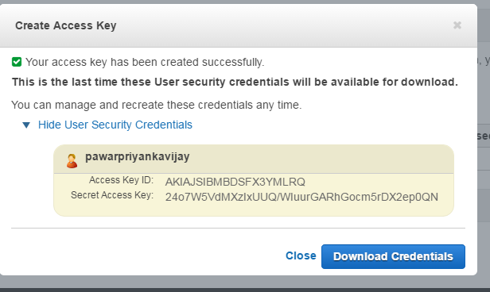

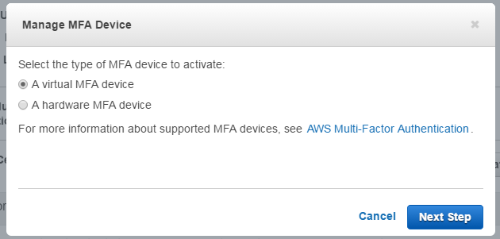

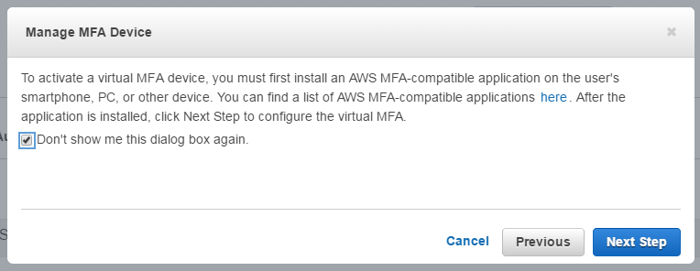

Step 8 : Setting permissions to users

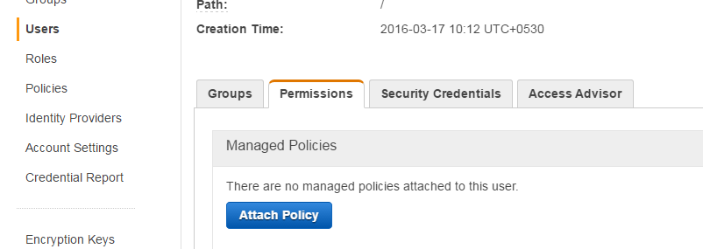

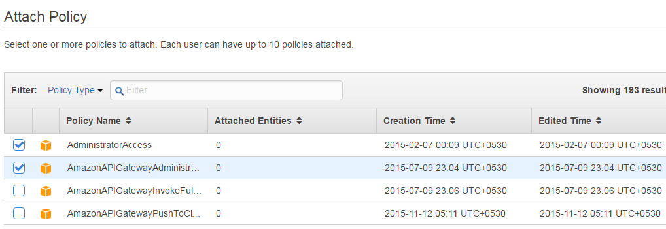

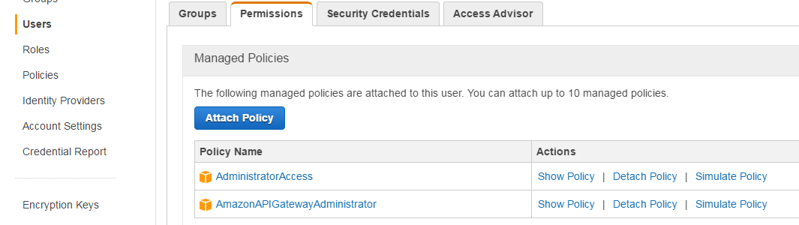

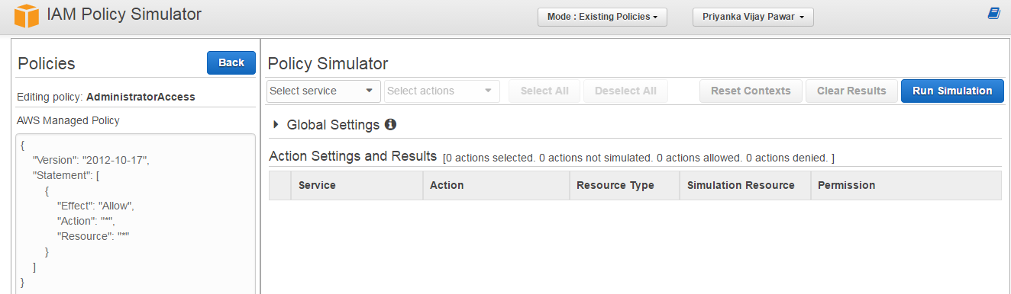

1. **Conclusion:**

We have studied how to secure the cloud and its data. Amazon EWS provides the best security with its extended facilities and services like MFA device. It also gives you the ability to add your own permissions and policies for securing data more encrypted.

**Experiment No. 6**

**Objective:** Working of Goggle Drive to make spreadsheet and notes.

**Requirement:** Google account, Internet Connection.

**THEORY:**

**Google Docs** is a free cloud-based suite of tools for creating documents, spreadsheets, presentations, and more. This tutorial will cover the **Spreadsheets** application in Google Docs, in addition to showing you how to access and store your Docs from **Google Drive**.

Google Docs, Sheets, and Slides are productivity apps that let you create different kinds of online documents, work on them in real time with other people, and store them in your Google Drive online — all for free. You can access the documents, spreadsheets, and presentations you create from any computer, anywhere in the world. (There's even some work you can do without an Internet connection!) This guide will give you a quick overview of the many things that you can do with Google Docs, Sheets, and Slides.

**Google Docs**

Google Docs is an online word processor that lets you create and format text documents and collaborate with other people in real time. Here's what you can do with Google Docs:

* Upload a Word document and convert it to a Google document
* Add flair and formatting to your documents by adjusting margins, spacing, fonts, and colors — all that fun stuff
* Invite other people to collaborate on a document with you, giving them edit, comment or view access
* Collaborate online in real time and chat with other collaborators — right from inside the document
* View your document's revision history and roll back to any previous version
* Download a Google document to your desktop as a Word, OpenOffice, RTF, PDF, HTML or zip file
* Translate a document to a different language
* Email your documents to other people as attachments

**Google Sheets**

Google Sheets is an online spreadsheet app that lets you create and format spreadsheets and simultaneously work with other people. Here's what you can do with Google Sheets:

* Import and convert Excel, .csv, .txt and .ods formatted data to a Google spreadsheet
* Export Excel, .csv, .txt and .ods formatted data, as well as PDF and HTML files
* Use formula editing to perform calculations on your data, and use formatting make it look the way you'd like
* Chat in real time with others who are editing your spreadsheet
* Create charts with your data
* Embed a spreadsheet — or individual sheets of your spreadsheet — on your blog or website

**Google Slides**

Google Slides is an online presentations app that allows you to show off your work in a visual way. Here's what you can do with Google Slides:

* Create and edit presentations
* Edit a presentation with friends or coworkers, and share it with others effortlessly
* Import .pptx and .pps files and convert them to Google presentations
* Download your presentations as a PDF, a PPT, or a .txt file
* Insert images and videos into your presentation
* Publish and embed your presentations in a website

# Create, name or delete a Google document

### Create a Google document

To create a new document, go to your Drive, click the **Create** button, and select **Document**.

A window with a new Google document will open, and you'll be able to edit the document, share it with other people, and collaborate on it in real-time. Google Docs saves your document automatically, and you can always access it from your Drive.

### Name a document

When you create a new document, Google Docs will name it **Untitled** by default.

To choose a name other than **Untitled**, click the **File** menu, and select **Rename**. From here you can choose and confirm your document's title. You can also edit the name by clicking the title displayed at the top of the page, and making your changes in the dialog that appears. Titles can be up to 255 characters long.

### Delete a document

#### Delete an item that you own from your Drive

1. From your Drive, select the item(s) you want to delete.
2. From the **More** menu, choose **Move to trash**.
3. If you're deleting a shared document that you own, you'll see an option to change the ownership of the document.
4. The item will be moved to the **Trash**.
5. To purge individual items from Trash, select them and choose **Delete forever**. To purge all your items click **Empty Trash** in the upper left.

# Create and save a document

There are different ways of getting started using Google documents: you can create a new online document, you can upload an existing one, or you can use a template from our templates gallery.

To create a new document, go to your Drive, click the red **Create** button, and select **Document** from the drop-down menu.

As soon as you name the document or start typing, Google Docs will automatically save your work every few seconds. At the top of the document, you'll see text that indicates when your document was last saved. You can access your document at any time by opening your Drive at http://drive.google.com.

To save a copy of a document to your computer, you can download it. In your document, go to the **File** menu and point your mouse to the **Download as** option. Select one of the following file types: HTML (zipped), RTF, Word, Open Office, PDF, and plain text. Your document will download to your computer.

# Upload a document

You can upload existing documents to Google documents at any time. When you're uploading, you can either keep your document in its original file type or convert it to Google Docs format. Converting your document to Google Docs format allows you to edit and collaborate online from any computer.

**Note:** When uploaded, images within a document are left as images (rather than being converted to text by Optical Character Recognition technology).

You can upload the following file types:

* .html
* .txt
* .odt
* .rtf
* .doc and .docx
* .pdf

Follow these steps to upload a document:

1. Click the **Upload** icon in the top left of your Documents List.
2. Click **Files...**, and select the document you'd like to upload.
3. Click **Open**.
4. Check the box next to 'Convert documents, presentations, spreadsheets, and drawings to the corresponding Google Docs format' if you'd like to be able to edit and collaborate on the document online. Uploaded document files that are converted to Google documents format can't be larger than 1 MB.
5. Click **Start upload**. The uploaded file will appear in your Documents List.

**Experiment No. 7**

**Objective:** Working and installation of Google App Engine.

**Requirement:** Login account codenvy.

**THEORY:**

# Deploying a New Application GAE

With Codenvy you can deploy Java, Python and PHP apps to Google App Engine.

* create a new project from scratch and choose either Java web application or Python and Google App Engine as PaaS (if you have already created a project, then open it and go to **PaaS > Google App Engine > Create Application**)
* enter project name and choose a **Template**
* check **Use existing GAE ID** if you want to overwrite an existing app
* click **Create** button
* if you deploy your first app to GAE from Codenvy you need to authenticate
* allow access to proceed
* enter required information at the GAE webpage (Application Title is optional)

[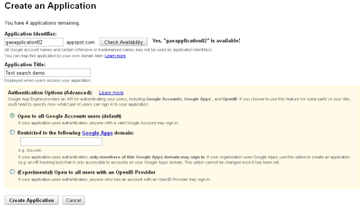](http://docs.codenvy.com/wp-content/uploads/gae_create.png)

Click to see a full sized image

* once you click **Create Application**, the browser’s tab will be automatically closed in a few seconds
* when you are back to your Codenvy workspace, click **Deploy** to push the app to GAE

The process may take several minutes, and you will see a confirmation message in the Output panel with the application url - yourappname.appspot.com

Make sure you use the same Google ID to log in to Codenvy and Google App Engine. Using different accounts may cause 401 or 404 errors. 401 error can be fixed by logging out, and then logging in Google App Engine at **PaaS > Google App Engine > Logout/Login**

Watch the entire process of deploying an app to GAE in the below video

# Updating an Existing Application GAE

Having deployed your application to GAE, you can make some changes to the code and easily update it.

* The application is updated at **Project > PaaS > Google App Engine**
* The project is re-built and re-deployed once you press **Application Update** button. An alternative way to update your GAE app is to go to **PaaS > Google App Engine > Update Application**.

[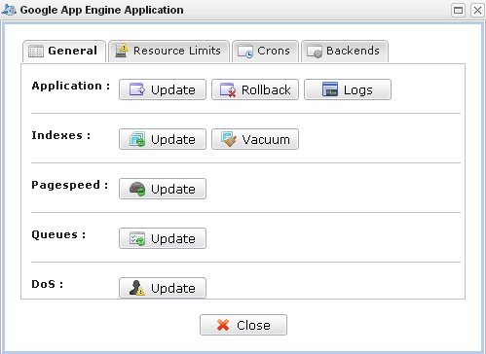](http://docs.codenvy.com/wp-content/uploads/gae_manage.png)

Three messages (project build, start and end of deployment) appear in the Output panel one by on. Once done, changes are implemented in the application hosted on appspot.com.

Have a look at this short video demonstrating how you can update your GAE apps directly from Codenvy:

# Managing GAE Applications

You can manage your GAE application at **Project  >PaaS > Google App Engine.**

It’s possible to modify and vacuum Indexes, PageSpeed, Queues, DoS as well as have a look at recourse limits, cron jobs and backends.

[](http://docs.codenvy.com/wp-content/uploads/gae_manage1.png)

# Import an Existing GAE Application

If you have a GAE application which you need to import to Codenvy, here’s a workaround (this is not a direct import of source code, so it will take a few minutes or so):

* download source code of your app (of course, this step can be omitted if you have in on GitHub and sync it regularly). You can download source code of your Java and Python apps using SDK command line (check out GAE documentation).
* push this code to GitHub or whatever remote repository you use
* clone your GitHub project to Codenvy
* open appengine-web.xml file and edit application ID, if necessary, for example <application>javagae112</application> (enter the app ID you need to update on GAE)
* if you want to create a new version of the same app, you can change it as well, for example <version>2</version>

<appengine-web-app xmlns="http://appengine.google.com/ns/1.0">

<application>java112</application>

<version>1</version>

* update application at**Project > PaaS > Google App Engine**.

Once the app is updated, you can change and update it anytime directly from Codenvy.

Since Codenvy uses Maven as a build manager, the projects you clone should also be built with Maven, i.e. contain pom.xml file in the root project folder.

You may have a look at this short video demonstrating the procedure of importing an existing GAE app to Codenvy using GitHub.

# Device Support

Codenvy currently supports all desktop and laptop devices. We currently provide touch device support through the use of the Puffin Web Browser which virtualizes double clicks and right clicks.  We have not yet created a native touch UI design. Vote for this feature at our Uservoice page.

**Experiment No. 8**

**Objective:** Working and installation of Microsoft Azure.

**Requirement:** Account on Microsoft Azure

**THEORY:**

##### Introduction:

In this article we are going to see how to create a new database stored procedure using the new Azure portal instead of using the SQL Server Management Studio.

##### Overview:

Stored procedures are created normally using the SQL Serve management studio, with the latest version of SQL Azure we have option to create a user stored procedure directly online without need to have a local interface. This way we have some control of using it anywhere anytime to do some updates regularly.

Let us see how to create the Stored procedure in Azure portal step by step.

##### Steps:

Log in to the Azure portal using the below link. You can see the screen look similar to below

http://www.microsoft.com/windowsazure/

[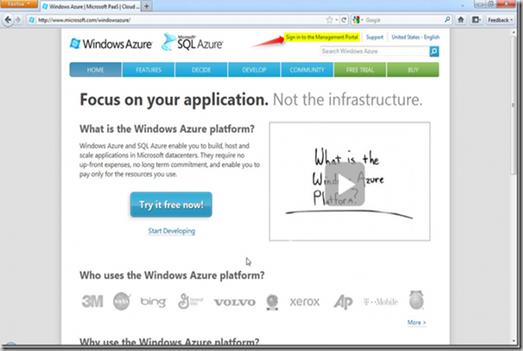](http://f5debug.net/image.axd?picture=clip_image002_4.png)

Login to the portal using your Microsoft Windows Live credentials with Azure credentials to the management portal and you will see the screen as shown in the screen below

[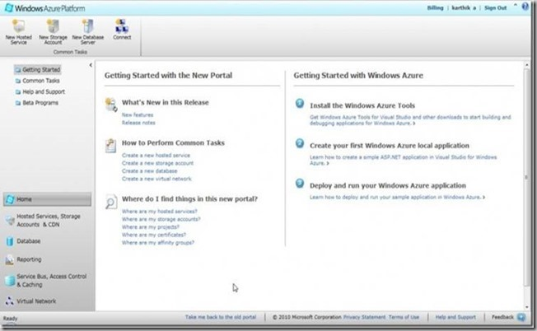](http://f5debug.net/image.axd?picture=clip_image004_51.jpg)

Now we can see the Database Menu at the bottom left, Click on that will go to the Database Subscription window as shown in the screen below

[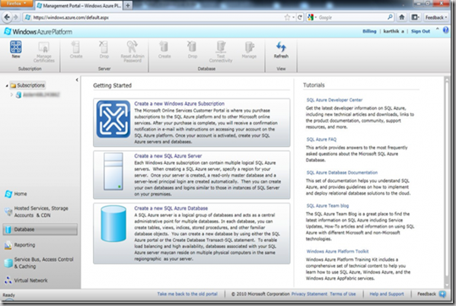](http://f5debug.net/image.axd?picture=clip_image006_11.png)

Clicking on the subscription name will provide the complete details of the server created and the new database created as shown in the screen below

[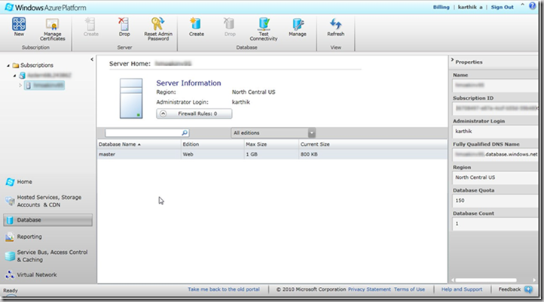](http://f5debug.net/image.axd?picture=clip_image008_8.png)

Now we have a database created(LearnAzure) with a Max size of 1GB and ready to use it for the application based on the requirement. To create a new Stored Procedure click on Manage at the top menu tool bar as shown in the screen below

[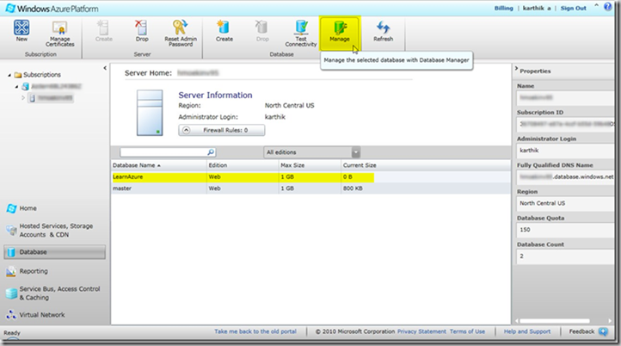](http://f5debug.net/image.axd?picture=clip_image010_6.png)

Check my previous article on how to connect to the manage portal using the credentials and the firewall using the link. Once logged in you screen will look like below

[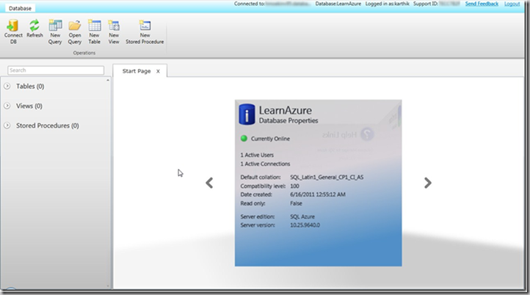](http://f5debug.net/image.axd?picture=clip_image012_6.png)

To create a new stored procedure click on New Stored procedure menu at the top and we will see a script window as shown in the screen below

[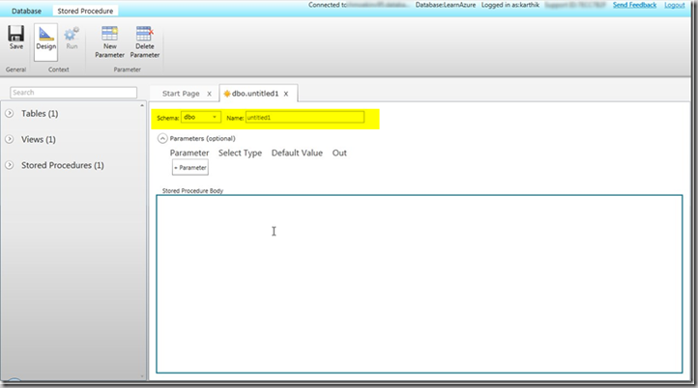](http://f5debug.net/image.axd?picture=clip_image013_5.png)

Now we will write our customized stored procedure for the EmpDetails table which we created in our earlier tutorial(Check my previous article for table creation) as shown in the screen below

[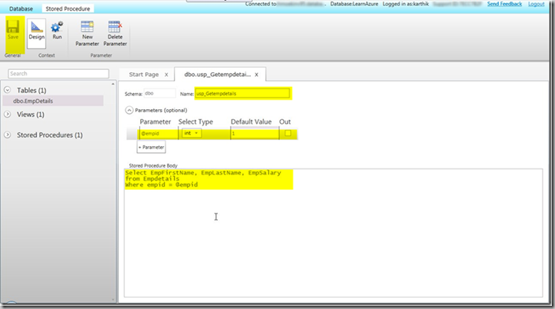](http://f5debug.net/image.axd?picture=clip_image014_4.png)Once we create the structure for the stored procedure as shown in the above screen we need to save it. Once save we can use the stored procedure to execute the same as shown in the screen below. We need to navigate to the new query window in the Database section and write a execute command as shown below.

[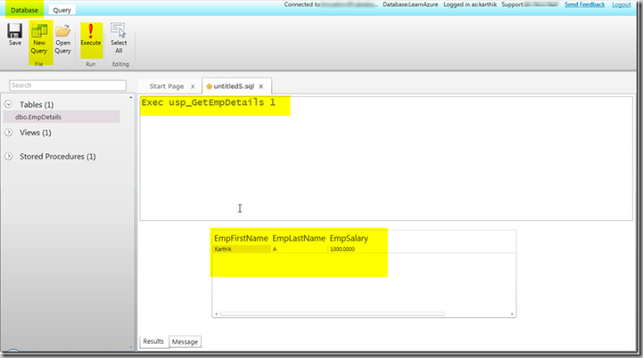](http://f5debug.net/image.axd?picture=clip_image015_3.png)

We can create n Number of stored procedure as per the requirement and use it across the process which we normally do with the traditional SQL Server locally.